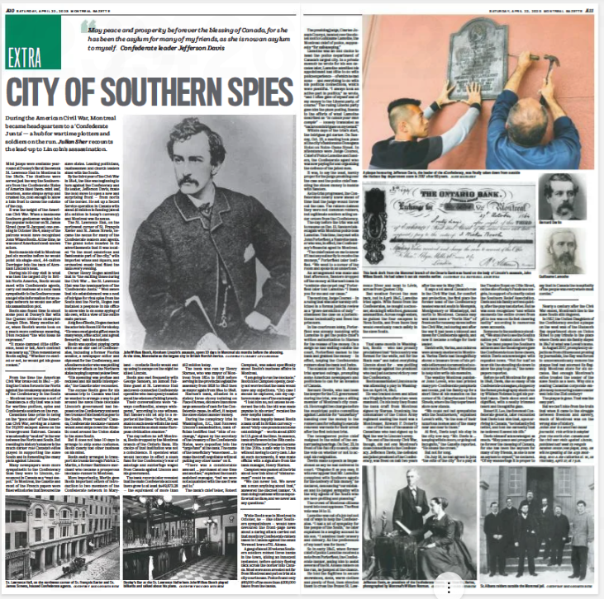
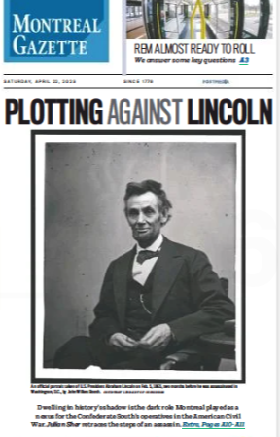

Plotting against Lincoln in Montreal,
city of Southern spies
Dwelling in history’s shadow is the dark role the metropolis played as a nexus for the Confederate South’s agents in the American Civil War.

Julian Sher • Special to Montreal Gazette, April 22, 2023
https://montrealgazette.com/news/local-news/plotting-against-lincoln-in-montreal-city-of-southern-spies
Mint juleps were available year-round at Dooley’s Bar at the swank St. Lawrence Hall in Montreal in the 1860s. The libations were served just the way the Southerners from the Confederate States of America liked them: mint leaf, bourbon, some simple syrup and crushed ice, cold enough to allow a thin frost to caress the outside of the cup.
It was the height of the American Civil War. When a handsome Southern gentleman walked into the popular hotel bar on St. James Street (now St-Jacques) one evening in October 1864, many of the patrons would have recognized John Wilkes Booth. At the time, he was one of American’s best-known actors.
Booth made his visit to Montreal just six months before he would point his single-shot, .44-calibre derringer into the back of Abraham Lincoln’s head.
During his 10-day visit in what was then the largest city in British North America, Booth would meet with Confederate agents, carry out business at a local bank sympathetic to the Southern cause and get vital information for an escape network he would use after his assassination plot.
Booth also found time to shoot some pool at Dooley’s Bar with the Quebec billiards champion Joseph Dion. Many months later, when Booth’s words took on a much more ominous meaning, Dion recalled “the wild ideas he expressed.”
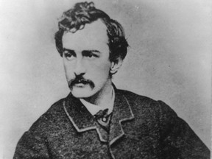

John Wilkes Booth, Abraham Lincoln’s killer, spent 10 days in Montreal just six months before the assassination. Photo courtesy U.S. Library of Congress.

From the time the American Civil War broke out in 1861 — pitting the Union forces in the North against the breakaway slave states of the Confederacy in the South — Montreal had become a sort of Casablanca: a city that was a hub for wartime plotters, spies and Confederate soldiers on the run.
“It made damned little difference, head or tail, Abe’s contract was nearly up,” Dion remembered Booth saying. “Whether re-elected or not, he would get his goose cooked.”
Canadians take pride in being on the “good side” of the American Civil War, serving as a haven for 30,000 escaped slaves on the Underground Railroad. Canada was ostensibly “neutral” in the war between the North and South. But dwelling in history’s shadow is the much darker role Canada’s elites played in supporting the slave South and in fomenting the many plots against Lincoln.
Many newspapers were more sympathetic to the Confederacy than they were to Lincoln, denounced in Canada as a “mad despot.” In Montreal, the Gazette and most of the French papers were filled with stories that favoured the slave states. Leading politicians, businessmen and church leaders sided with the South.
By the third year of the Civil War in 1864, the tide was beginning to turn against the Confederacy and its leader, Jefferson Davis, made the bold move to open a new and surprising front — from north of the border. He set up a Secret Service operation in Canada with about $1 million in funding (about $16 million in today’s currency) and Montreal was its nexus.
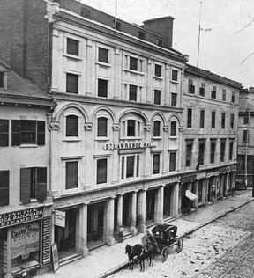

The St. Lawrence Hall, a hotel on the northwest corner of St. François Xavier and St. James Streets, housed many Confederate agents. Photo courtesy McCord Museum.

The St. Lawrence Hall, on the northwest corner of St. François Xavier and St. James Streets, became the nexus for many of the Confederate leaders and agents. The grand hotel boasted in its advertisements that it was located “in the most salubrious and fashionable part of the city,” with imported wines and liquors, and orchestral music that filled the halls every evening.
Owner Henry Hogan admitted that in “the exciting times during the Civil War … the St. Lawrence Hall was the headquarters of the ‘Confederate Junta.’” Well aware that his establishment was a nest of intrigue for rival spies from the South and the North, Hogan had installed a peephole in his office to allow him to do some spying of his own, with a view of the entire main parlour.
A big fan of Booth, Hogan checked the actor into Room 150 for his stay. “He was a most genial gifted man in many ways, a fine actor, and a great favourite,” said the hotelier.
Booth was spotted playing cards with an all-star cast of Confederates, including a former Florida senator, a newspaper editor and diplomat for the Confederacy, and a Southern doctor who was plotting a bio-terror attack on the Northern states hoping to spread yellow fever.
“His spending was profuse and reckless and his habits intemperate,” the Gazette later recounted.
The excuse Booth gave for his unusual trip to Canada was that he wanted to arrange a way to get around the naval trade blockade Lincoln’s government had imposed on the Confederacy and send two trunks of his theatrical gear to the South. From “neutral” Canada, Confederate blockade-runners would send ships down the Atlantic coast around the Union states to the slave South.
But it does not take 10 days to arrange to ship some costumes. Booth clearly had other business on his mind.
Booth easily arranged to transport his trunks through Patrick C. Martin, a former Baltimore merchant who became a prosperous blockade-runner in Montreal.
More importantly, Martin gave Booth important letters of introduction to two members of the Confederate network in Maryland — contacts Booth would end up using to escape on the night he killed Lincoln.
Booth also met frequently with George Sanders, an almost full-time guest at St. Lawrence Hall and a well-connected Confederate operative who had openly boasted about the wisdom of killing tyrants.
Their conversations were “always confidential, always whispered,” according to one witness. But Sanders did let slip to a reporter at the time: “In fact, Sir, we shall do such deeds within the next three months as shall make European civilization shudder.”
The day before he left Montreal, Booth dropped by the Montreal branch of the Ontario Bank. His choice of that institution was not a coincidence. It operated what would become in effect a slush fund for the Confederacy’s war of sabotage and subterfuge waged from Canada against Lincoln and his government.
The bank records later revealed that the main Confederate account there grew to at least $649,873.28 — the equivalent of more than $12 million today.
The bank was run by Henry Starnes, who was mayor of Montreal from 1856 to 1858 before serving in the provincial Legislative Assembly from 1858 to 1863 then as mayor again from 1866 to 1868.
Starnes’s bank, situated in a stately three-storey building on Place d’Armes, did more than move large amounts of cash for the Confederate cause; in effect, it helped the slave states launder money.
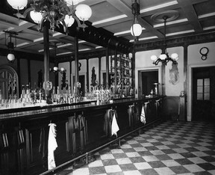

Dooley’s Bar at the St. Lawrence Hall, where John Wilkes Booth played billiards. Photo courtesy McCord Museum.

During the conspiracy trial in Washington, D.C. that followed Lincoln’s assassination, bank officials testified that “bills of exchange,” signed by the secretary of the treasury of the Confederate States, were deposited into the “large fund” at the bank. The name of the beneficiary “was erased … to make the draft negotiable without putting any other name” on it.
“There was a considerable amount … purchased at one time and another,” explained the bank’s assistant manager, “but we were not acquainted with the use it was put to.”
The bank’s chief teller, Robert Campbell, was asked specifically about Booth’s business affairs in Montreal.
“I am going to run the blockade,” Booth told Campbell openly, clearly not worried that the bank would have any objections. “(In) case I should be captured, can my capturers make use of the exchange?”
“I told him no, not unless he endorsed the bill: the bill was made payable to his order,” recalled the ever-helpful banker.
The bank happily issued Booth a bank draft in British currency — about “sixty-one pounds and some odd shillings” — worth about $300 in U.S. gold at the time. In essence, bank drafts were in the 19th century what traveller’s cheques became in the 20th: a safe way to travel without having to carry cash. Like all such documents, it was made official with a signature from the bank manager, Henry Starnes.
Campbell was pushed at the trial about how this kind of “disbursement” could be used.
“We can never tell. We never ask a man anything about that,” answered the discreet banker. “A man doing business with us deposits what he likes; and we never ask any questions.”
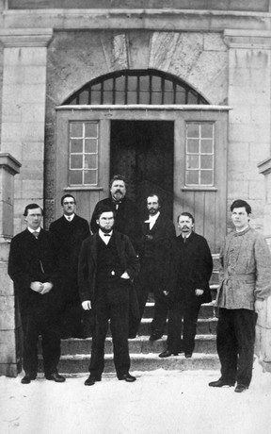

The St. Albans raiders outside the jail in Montreal. Photo courtesy McCord Museum.
While Booth was in Montreal in October, he — like other Southern sympathizers — would have devoured the front-page news about a daring attack carried out that month by Confederate raiders based in Canada against the small Vermont town of St. Albans.
A gang of about 20 veteran Southern soldiers robbed three banks in the town, killing an innocent bystander, before quickly fleeing back across the border into Canada. Most were soon arrested not far from Montreal and put on trial at a city courthouse. Police found only $90,000 of the more than $200,000 taken from the banks.
The presiding judge, Charles-Joseph Coursol, handed over the stolen loot to Guillaume Lamothe, the Montreal chief of police, supposedly “for safe-keeping.”
Lamothe was an odd choice to head the police department of Canada’s largest city. In a private memoir he wrote for his son decades later, Lamothe admitted his appointment had little to do with police experience — of which he had none — and everything to do with his political connections, which were plentiful. “I always took an active part in politics,” he wrote, “and I often gave of myself and of my money to the Liberal Party, of course.” The ruling Liberal Party gave him the plum posting, thanks to the efforts of what Lamothe described as “la cabale pour mon compte” — loosely translated as “backroom intrigues on my behalf.”
Within days of the trial’s start, the intrigues got darker. On Sunday, Oct. 23, a meeting took place at the city’s fashionable Donegana Hotel on Notre-Dame Street. In attendance were Judge Coursol, Chief of Police Lamothe and Sanders, the Confederate agent who was now paying for and organizing the defence of the jailed men.
It was, to say the least, hardly proper for the judge presiding over the case and the police chief handling the stolen money to huddle with Sanders.
As the trial progressed, the Confederates clearly knew ahead of time that the judge would throw out the case. The raiders claimed they were not common robbers, but legitimate soldiers acting under orders from the Confederacy.
The day before the trial was set to resume on Dec. 13, Sanders talked again with Montreal police boss Lamothe. This time, they met with John Porterfield, a Nashville banker who was, in effect, the Confederacy’s financial agent in Montreal.
“The chief called on me to know if I had any authority to receive the moneys,” Porterfield later testified. “We went to a corner of the room and spoke in an undertone.”
An arrangement was made and that afternoon, Sanders dropped off the money at Starnes’s bank in “a middle-size carpet bag.” Porterfield later told Lamothe: “I thank you for me and our cause.”
The next day Judge Coursol — in a ruling that was later harshly criticized in a formal judicial review as a “grave dereliction of duty” — dismissed the case on a jurisdictional technicality and freed the prisoners.
In the courtroom lobby, Porterfield was already huddling with Lamothe to get the police chief’s written authorization to Starnes for the release of the money. On a sleigh he had waiting outside the court, Porterfield dashed to the bank and grabbed the money — in effect, helping the Confederates robbers steal the bank loot twice.

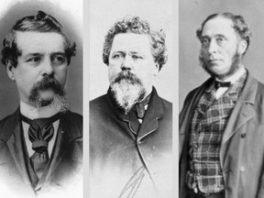

From left: Bernard Devlin denounced Montreal’s police chief for collaborating with Confederates; George Sanders, a Confederate operative who met with John Wilkes Booth in Montreal; Henry Starnes ran the Ontario Bank branch that helped finance the Confederate operation. Photos courtesy McCord Museum.

The scandal over the St. Albans trial sparked outrage, prompting some American newspapers and politicians to call for an invasion of Canada.
Bernard Devlin, who had been the lawyer for the U.S. government during the trial, was also a sitting member of Montreal’s city council. He brought two charges before the municipal police committee against Lamothe for “unlawfully” handing over the money to the robbers and for refusing to execute renewed warrants for their arrest after the first botched trial.
The beleaguered police chief resigned in the midst of the embarrassing hearings. On Dec. 23, in front of the full city council, came the vote on whether or not to accept his resignation.
Devlin made a speech as impassioned as any he had delivered in court. “Disguise it as you may, it will ever appear that Mr. Lamothe conspired with Southern agents for the delivery of this money,” he declared, denouncing “our mistaken and ill-judged sympathy with the wily agents of the South who are here plotting and planning.”
The crowd of Montreal citizens burst into loud applause. The final vote was 14 to 11.
Lamothe was out of a job but not out of ways to help the Confederates. “I had a lot of sympathy for the people of the South,” he later explained in a lengthy account to his son. “I admired their bravery and chivalry. All the preferences of my heart was for them.”
So in early 1865, when the former chief of police Lamothe received a note from Porterfield, the Confederate banker, asking him to assist several of the St. Albans raiders on the run, he jumped at the chance.
He told the fugitives to secure snowshoes, sleds, warm clothes and plenty of food, then directed them to cross the frozen St. Lawrence River and head to Lévis, across from Quebec City.
Bad weather forced the men back, but in April 1865, Lamothe tried again. With funds from the Confederates, he bought a schooner, stocking it with food, guns and ammunition. Across rough waters, he guided the four escapees to Nova Scotia, and from there they would eventually reach safety in the slave South.

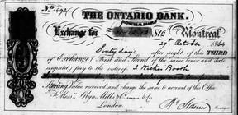Bank draft from the Montreal branch of the Ontario Bank found on the body of Lincoln’s assassin, John Wilkes Booth. Photo courtesy U.S. National Archives.
That same month in Washington, Booth — who had proudly proclaimed that “this country was formed for the white, not for the black man” and hated everything Lincoln stood for — was plotting his revenge against the president who had just declared victory over the Confederacy.
Booth assassinated Lincoln as he was attending a play in Washington on April 14, 1865.
He was tracked down and killed on a Virginia farm after a two-week manhunt. On his body they found the bank draft from Montreal signed by Starnes. Ironically, the commander of the Union Army regiment leading the hunt was a Montrealer, Edward P. Doherty — one of the tens of thousands of Canadians who had signed up to fight the war in Lincoln’s army.
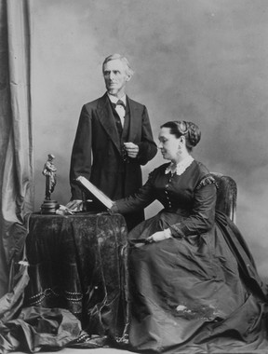

Jefferson Davis, ex-president of the Confederate States, and his wife, Varina, photographed by William Notman during their stay in Montreal in 1867. Photo courtesy McCord Museum.

The end of the bloody Civil War, though, did not end Montreal’s close connections to the Confederacy.
Jefferson Davis, the defeated and jailed president of the Confederacy, was freed on bail two years after the war in May 1867.
It says a lot about Canada’s role in the Civil War that, for comfort and protection, the first place the former head of the Confederacy headed was not south to Memphis, Montgomery or Mississippi, but north to Montreal. Canada may well have been a “North Star” of freedom for runaway slaves before the Civil War, but during and after the war it had been a hideout and haven for Confederate agents, and now it became a refuge for their leader.
Davis’s wife, Varina, and children were already sheltered in Montreal. Varina Davis had thoughtfully stored a treasure trove of his private letters and documents at a local branch of the Bank of Montreal to help him write his memoirs.
The wealthy Montreal publisher John Lovell, who had printed many pro-Confederate pamphlets and books, put the family up for a short time at his mansion on the corner of St. Catherine and Union Streets, where the Bay department store now stands.
“We could not but sympathize with the Southerners,” explained Lovell’s wife, “in the loss of their luxurious homes and of the many near and dear to them.”
At first, Davis kept his stay in the city low-key. “Mr. Davis is … keeping within doors, or going out incognito,” the Gazette reported. “He shuns the crowd.”
But not for long.
On July 18, he had agreed to join “the elite of the city” for a play at the Theatre Royal on Côte Street, on the site of today’s Palais des congrès, in support of a charity called the Southern Relief Association. Davis and his family arrived quietly, after the play had started. But he was soon recognized “and within moments the entire crowd from pit to box was on its feet cheering lustily” according to numerous news accounts.
Someone in the audience shouted, “We shall live to see the South a nation yet.” Amidst calls for “Dixie,” the band played the Southern anthem and the theatre-goers gave the Confederate icon three cheers, which Davis acknowledged with repeated bows. “Not for half an hour did the shouting die down to allow the play to go on,” the newspapers reported.
Before he left Montreal for good in 1868, Davis, like so many of his Confederate colleagues, stopped by the famed photography studio run by William Notman to get his portrait taken. Davis stood erect and dignified, with a neatly trimmed beard and thoughtful gaze.
Robert E. Lee, the foremost Confederate general, later recounted that Davis told him that, upon arriving in Canada, “he instantly felt better, and told me earnestly that he believed it saved his life.”
Davis himself acknowledged as much: “May peace and prosperity be forever the blessing of Canada, for she has been the asylum for many of my friends, as she is now an asylum to myself,” he declared. “Of my wanderings it is proper to say that in Canada the hospitality of the slave South still lingered.”
In 1957, the United Daughters of the Confederacy erected a plaque on the west wall of the Hudson’s Bay department store on Union Street to pay tribute to the place where Davis and his family stayed in 1867 at what was then Lovell’s home.
In August 2017, prompted by objections from citizens and probing by journalists, the Bay was forced to unceremoniously remove the plaque that had adorned its flagship Montreal store for six decades. Bad enough Montreal’s elites treated the leader of the slave South as a hero. Why did a leading Canadian corporate empire keep honouring a slave leader well into the 21st century?
The plaque is gone. That was the easy part. But we can’t hide from the truth that when it came to the struggle between freedom and slavery, much of Montreal was on the wrong side of history.
_________________________________

